Patient and Public Involvement: the importance of closing the loop in research.
Miss Lauren Powell¹, Dr Jack Parker¹, Dr Ben Heller², Miss Eileen Schweiss³, Professor Susan Mawson¹
University of Sheffield¹; Sheffield Hallam University², RunScribe³

^{Table of contents}
Introduction 1
Method 2
Participants 3
Presentation of feedback 3
Results 4
Future directions 4
PPI: what’s next? 4
Difficulties encountered 4
Acknowledgments 4

Introduction
Globally, the incidence of stroke is predicted to increase from 15.3million to 23 million by 2030 [1]. The largest cause of disability in the United Kingdom (UK) is stroke [2], which costs the economy £8.9 billion a year [3]. Following a stroke, around 15% of survivors will be able to function using their upper and lower limbs [4]. The key priority of rehabilitation according to stroke survivors following a stroke is to make sure they are able to walk and remain mobile [5] rather than focusing on arm and hand function. However, arm and hand function is important for many reasons including carrying out every day activities [6] such as eating, writing, personal care and maintaining a good quality of life [7].
Unfortunately, with an increasingly ageing population the demands on the NHS are increasing and these demands are a struggle to meet. Therefore other interventions have been used to try and help stroke survivors self-manage their rehabilitation and disabilities [8]. In recent years, these interventions have more often been in the form of technology [9].

It is also widely reported that feedback is important for effective motor learning following a stroke [10]. There is also a well-evidenced theory of Constraint Induced Movement Therapy (CIMT) that states that forcing the movement of the weaker limb will help improve recovery [11, 12]. This can be done by securing the patient’s stronger limb in to a sling to prevent them from being tempted to use it, thus encouraging the use of the free weaker limb. Based on the importance of feedback and CIMT, University of Sheffield researchers have conducted a feasibility study assessing the feasibility of stroke survivors (and age matched controls) wearing inertial sensors; one on each wrist. These inertial sensors measured upper limb movements but did not track the individuals’ geographical locations. The future goal is for these sensors to be embedded in a wrist worn device (like a watch) that can provide feedback to the user (stoke survivor) on how much their arms are moving to encourage them to use their weaker limb.
In order to reach this goal, the team firstly conducted a feasibility study to see if a) stroke survivors and age matched controls would be willing to wear these sensors, b) to find out if the sensors recorded a clear different between stroke survivors and age matched controls and c) to see if the data analysis methods proposed were also feasible. Participants’ wore the sensors (without feedback from the sensors) for 96 hours to help answer these questions. We also carried out the Action Research Arm Test (ARAT), which is a measure of the stroke survivor’s capability to use their affected upper-limb. The ARAT score is from zero (no capability) to 57 (full capability). This enabled us to explore an association between the sensor data and the participant’s capability of using their affected upper-limb. All of the above has proved to be positive in that everybody was happy to wear the sensors for 96 hours, the data was different between the two groups, patterns in the data were identified and the data analysis methods proposed were feasible.

The research team believe it is important to “close the loop” in research and provide participants with study results where possible for a number of reasons including the participants being able to see the end result of what they have contributed towards as well as to potentially improve recruitment to the study. The team also believe that members of the public should have a say in terms of the form their results should take in order to make it as accessible as possible so that it can reach a wider audience [13]. This is particularly important for this research as we have a mixture of communication needs in the study sample including stroke survivors and people living with aphasia. Individualised graphs were made available to each participant so that they could see their upper limb movements compared to their age matched control over the 96 hours they wore the sensors. Therefore, this paper will report on the feedback from study participants about the way in which we presented study results to them so that we can provide the best quality, and most accessible feedback possible for our participants in the future.

Method
In the feasibility study described above, there was a clause on every consent form that participants signed if they wished to receive the study results at the end of the study. 59 out of 60 participants opted to receive the study results and these individuals were contacted at the end of the study by telephone, post or email based on their preferred contact method. This in itself highlights the importance of providing results for participants. The study team was also invited to visit a stroke community group in Sheffield at the end of the study whereby a number of attendees took part. Table 1 presents the demographics of the study sample and their ARAT score. Additionally, anonymised interim results were presented at a number of stroke community groups during the recruitment phase of the study.

Participants

Diad ID | Time since stroke (years) | SS* Gender | Age (SS) | ARAT* Score | Dominant arm (SS) | Affected limb | C* Gender | Age (C) | Dominant arm (C)
1 | 12 | M | 72 | 0 | L | R | F, R | 71 | R
2 | 5 | M | 66 | 0 | L | R | F, R | 60 | R
3 | 5 | M | 66 | 57 | R | L | F, R | 47 | R
4 | 10 | F | 65 | 57 | R | L | M, R | 66 | R
5 | 5 | F | 66 | 37 | R | R | M, R | 65 | R
6 | 3 | F | 80 | 57 | R | R | F, R | 57 | R
7 | 2.5 | M | 67 | 57 | R | L | F, R | 62 | R
8 | 10 | M | 64 | 0 | R | R | F, R | 66 | R
9 | 5 | F | 49 | 42 | R | R | F, R | 65 | R
10 | 10 | M | 55 | 4 | R | R | F, R | 48 | R
11 | 7 | F | 44 | 0 | R | R | M | 60 | L
12 | 4 | M | 76 | 15 | R | L | F | 76 | R
13 | 3.5 | F | 69 | 57 | R | L&R (R>) | M | 70 | R
14 | 2 | F | 67 | 57 | R | R | M | 68 | R
15 | 3 | M | 84 | 57 | R | R | F | 83 | R
16 | 21 | F | 55 | 0 | R | R | M | 57 | R
17 | 1.5 | F | 60 | 57 | R | R | F | 69 | R
18 | 6 | F | 33 | 5 | R | R | M** | 31 | R
19 | 3.5 | M | 45 | 45 | R | R | M | 45 | R
20 | 4 | M | 49 | 57 | R | R | F | 45 | R
21 | 1.5 | M | 63 | 57 | R | R | F | 58 | R
22 | 5 | F | 46 | 57 | R | R | F | 54 | R
23 | 2 | M | 71 | 57 | R | R | F | 72 | R
24 | 1 | F | 52 | 0 | R | L | M | 68 | R
25 | 4 | F | 64 | 45 | R | R | M | 69 | R
26 | 4 | M | 63 | 0 | R | L | F | 64 | R
27 | 4 | F | 64 | 0 | R | R | F | 60 | R
28 | 2 | M | 70 | 57 | R | R | M | 71 | R
29 | 2 | M | 68 | 57 | R | L | F | 67 | R
30 | 9 months | M | 64 | 57 | R | L | F | 60 | R
Table 1: Participant demographics
SS* Stroke Survivor
C* Control
R* Right
L* Left
ARAT* Action Research Arm Test
**Participant did not request study results

Presentation of feedback
Results were presented in the form of individualised graphs (see figures 1-3) that were explained to them by a member of the research team. The graphs showed a summary of how much each limb moved throughout the duration of the study, compared to the age matched control. The graphs also included a summary of the dominant arm of each participant, the limb affected by the stroke and the Action Research Arm Test (ARAT) score of the stroke survivor. The ARAT measures the individual upper limb capabilities [14]. The maximum score on the ARAT was 57, which meant that the participant was able to complete the entire measure.
The research team member requested feedback from participants about if they understood their graphs, if they liked or disliked them and why, and what could be done to improve the graphs.

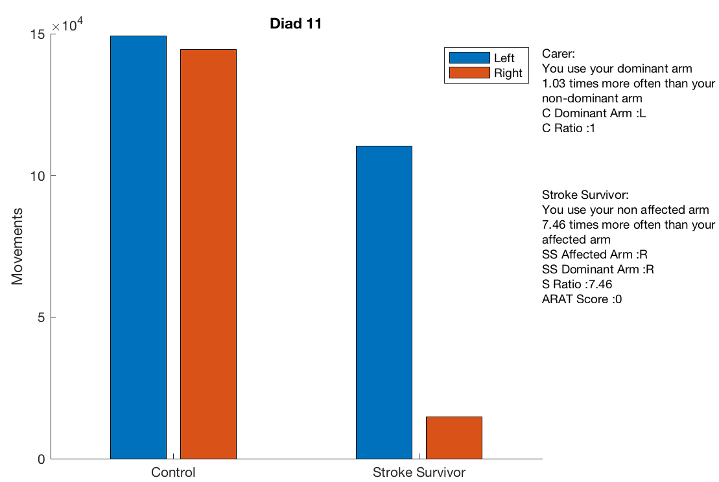
Figure 1: The stroke survivor presented above had zero use of their (right) affected limb and obtained a score of zero o the ARAT.

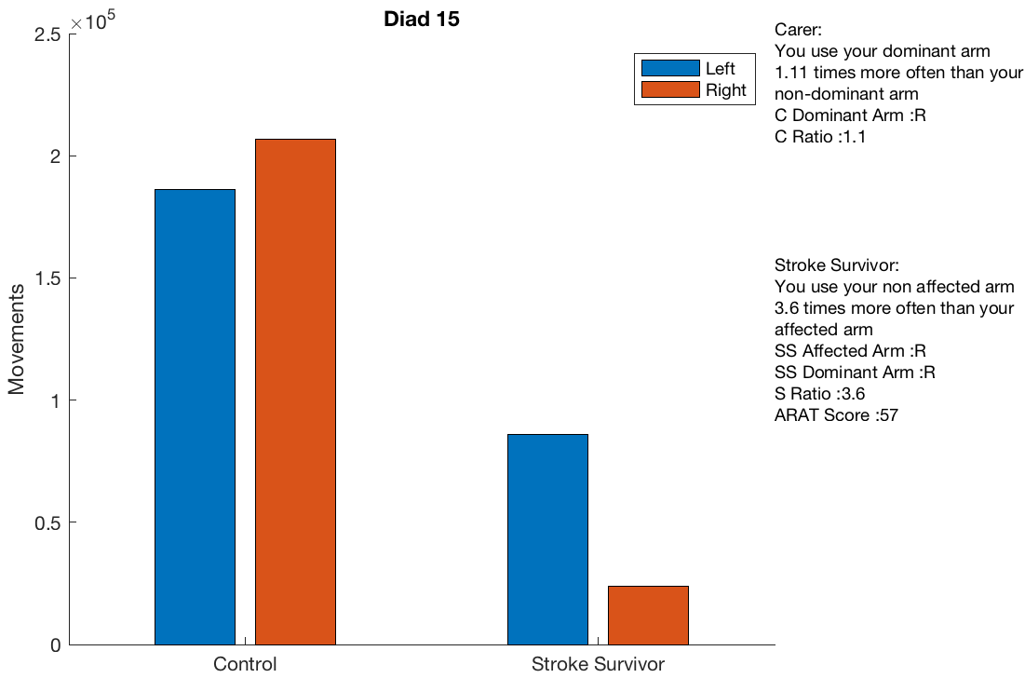
Figure 2: The stroke survivor in diad 15 obtained the top score of 57 on the ARAT suggesting they have full functionality of both of their upper limbs. However, they clearly used their affected dominant arm (right) less than their non-dominant non-affected limb.

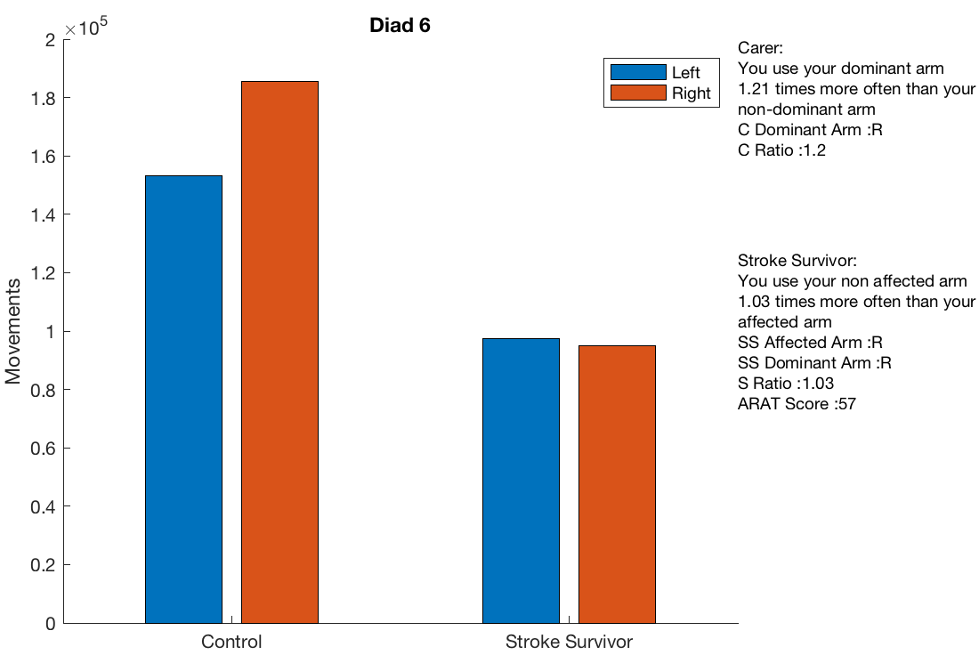
Figure 3: The stroke survivor in diad 6 had full functionality of both of their limbs and obtained a top score of 57 on the ARAT.

Results
Figures one to three demonstrate the broad variety of capabilities participants had. It also shows that those who thought they had full functionality of both of their limbs even though this was not always the case. Participants at community groups found this fascinating when the anonymized results were presented to them part way through the projects recruitment phase, these interim results enabled potential participants to visualise what their results might be and therefore what they would learn about themselves having taken part in the study. It was apparent that this additional information other than just a standard participant information sheet and question and answer sessions increased the uptake of participants.

When participants were presented with their individualised graphs, the overall feel was that they also wanted a graph that showed all participants so they could see how they compared to others (see figure 4) and that they were interested to see their own scores. For example, one participant stated that;

“It’s infuriating to take part in research where the results aren’t shared with you- it would be disrespectful not to share it. The main surprise for me was the amount that I did seem to be moving my affected arm I expected the differential to be greater given that I have so little use of it. I would like to know a bit about your overall results and what you plan to do next.” (SS24)

Two participants stated that they found the graphs “straightforward” but would have preferred percentages rather than ratios to demonstrate right/left arm usage (SS20/CC20). One participant appreciated the colours on the graph and liked that they could see their ARAT score (SS1/CC1, C15/SS15). Another participant said they would have preferred more “accompanying text” with their graph to explain it further (SS13).

One participant even stated that they are now making a conscious effort to use their effected arm more than before;

“My right arm more active than left arm which I already knew its me left arm that’s been affected by me stroke. Yes I found that since then I’ve used my left arm more and it is never going to catch my right arm up but it is much more active now than before.” (SS12)

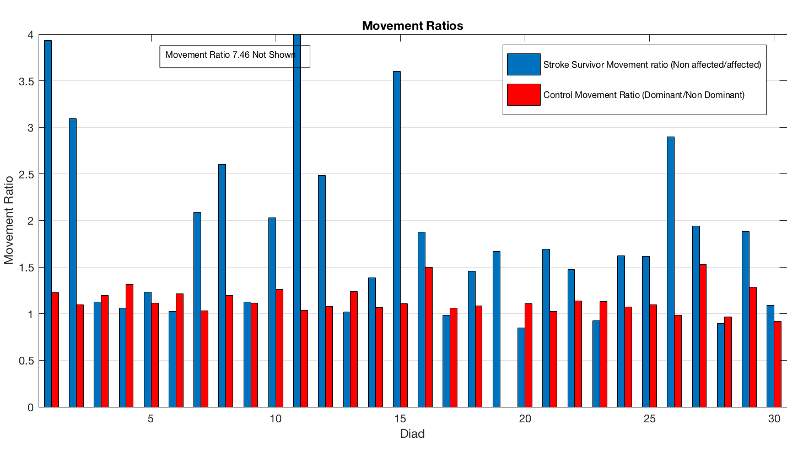

Figure 4: Graph presenting all participant scores.

PPI: what’s next?
Feedback from our participants shows that people are keen to find out what the results are of research that they take part in. One person even felt it to be disrespectful to not share results with them. It is also important when providing results to explore with the participants the most appropriate way of presenting their results.
Researchers also visited a stroke community group at the end of the study to share results with participants and also others who did not take part in the study were present. All of these individuals, regardless of whether they took part or not were keen to understand the project and wanted to assist in future projects if possible. This shows the importance of including participants in research can help them understand what they are assisting with provides them with an incentive to help with future research and generates interest around the research area. Therefore, we will continue this practice for future research projects to ensure our participants continue to feel valued and included in the research process fall the way to the end of the research.

Acknowledgments
This research was funded/supported by the National Institute for Health Research Collaboration for Leadership in Applied Health Research and Care Yorkshire and Humber. The views and opinions expressed are those of the authors and are not necessarily those of the National Health Service, the National Institute for Health Research, or the UK’s Department of Health

References

1. Strong, K., C. Mathers, and R. Bonita, Preventing stroke: saving lives around the world. The Lancet Neurology, 2007. 6(2): p. 182-187.
2. Health, D.o., National Stroke Strategy. 2007: London.
3. Saka, Ö., A. McGuire, and C. Wolfe, Cost of stroke in the United Kingdom. Age and ageing, 2009. 38(1): p. 27-32.
4. Hendricks, H.T., et al., Motor recovery after stroke: a systematic review of the literature. Archives of physical medicine and rehabilitation, 2002. 83(11): p. 1629-1637.
5. Luker, J., et al., Stroke survivors' experiences of physical rehabilitation: a systematic review of qualitative studies. Archives of physical medicine and rehabilitation, 2015. 96(9): p. 1698-1708. e10.
6. Houwink, A., et al., Functional recovery of the paretic upper limb after stroke: who regains hand capacity? Archives of physical medicine and rehabilitation, 2013. 94(5): p. 839-844.
7. Rosenthal, O., et al., Mapping upper-limb motor performance after stroke-a novel method with utility for individualized motor training. Journal of neuroengineering and rehabilitation, 2017. 14(1): p. 127.
8. Langhorne, P., F. Coupar, and A. Pollock, Motor recovery after stroke: a systematic review. The Lancet Neurology, 2009. 8(8): p. 741-754.
9. Powell, L., et al., The effectiveness of lower-limb wearable technology for improving activity and participation in adult stroke survivors: a systematic review. Journal of medical Internet research, 2016. 18(10).
10. Subramanian, S.K., et al., Does provision of extrinsic feedback result in improved motor learning in the upper limb poststroke? A systematic review of the evidence. Neurorehabilitation and neural repair, 2010. 24(2): p. 113-124.
11. Taub, E., et al., A placebo-controlled trial of constraint-induced movement therapy for upper extremity after stroke. Stroke, 2006. 37(4): p. 1045-1049.
12. Wolf, S.L., et al., Effect of constraint-induced movement therapy on upper extremity function 3 to 9 months after stroke: the EXCITE randomized clinical trial. Jama, 2006. 296(17): p. 2095-2104.
13. INVOLVE, Briefing notes for researchers: Involving the public in NHS, public health and social care research. 2012.
14. Lyle, R.C., A performance test for assessment of upper limb function in physical rehabilitation treatment and research. International Journal of Rehabilitation Research, 1981. 4(4): p. 483-492.

