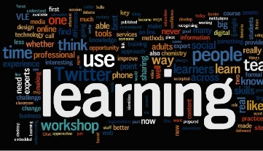 Learning and Development Project Group
What do I need for my role?
The table below helps you to decide the skills, knowledge or experience that might support you in a role or activity – and it considers which of these you already have, and whether these might need updating or developing. We encourage you to discuss this with your involvement contact or coordinator.
- Role or activity needs | - Skills or knowledge needed | - Existing experience,  knowledge and skills |  |  | - How do you like to learn or develop skills?
Look at the role description or activity you are involved in. List the things you are likely to be doing, or the ‘person specification’ list in the role description. | Think about what experience, knowledge and skills you might need in this role, or to complete these activities. | Everyone brings their own set of experience, knowledge and skills, picked up in life, at work, or developed in other activities and roles. Do these match any of the needs of the role or activity, or are these things you need? |  |  | Think about how you prefer to learn, pick up information or develop new skills. Some like formal group training, while others prefer on-line training that can be done at home. Some like to learn by doing the role. How would you prefer to learn or develop these areas?
 |  | Existing, and  up-to-date | Existing, but needs updating | No previous experience

- Role or activity needs | - Skills or knowledge needed | - Existing experience,  knowledge and skills |  |  | - How do you like to learn or develop skills?
 |  | Existing, and  up-to-date | Existing, but needs updating | No previous experience

